**APACHE WEB SERVER**

**HOW TO CREATE ACCOUNT ON APACHE:**

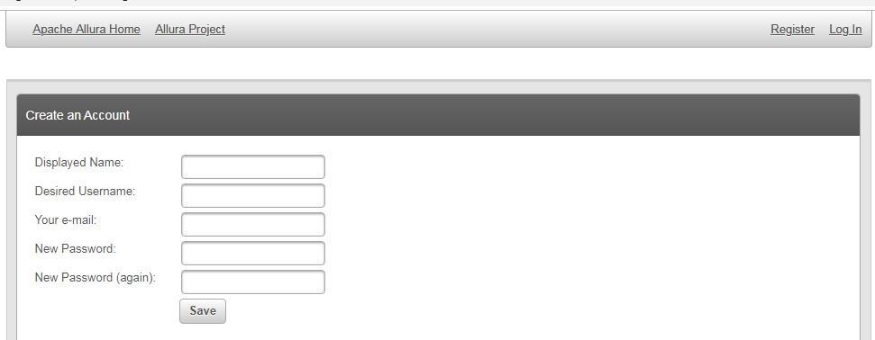

1. In order to create an account on apache web server, firstly open the official website of apache- [www.apache.org](http://www.apache.org/)
2. A page like the above image will be displayed, click on **register** option seen at the right hand top corner.
3. Fill in the required details and then click on **save**. Thus your account will be created.

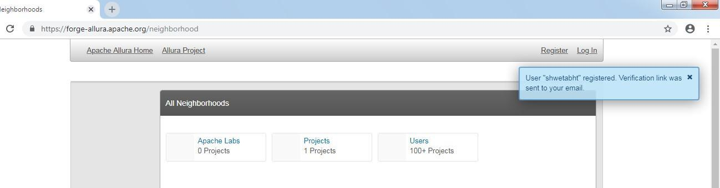

1. After creation of the account, a **verification** email will be sent to the inputted user email id. In order to verify the account, follow the instructions written on the email sent as shown in above image.
2. Click on **login** option besides register, fill username and password n then login to your account and start contributing.

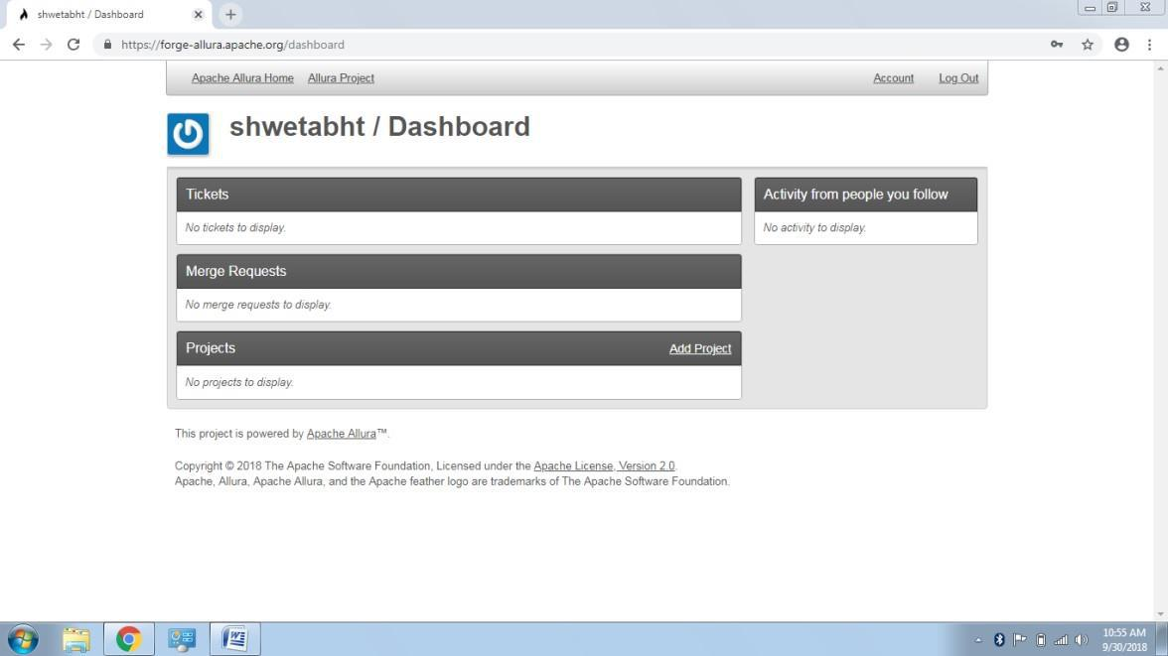

1. In order to **contribute**, to the apache server, click on **add a project** option mentioned on the displayed page e.g. shown in above image. 7. A page will be displayed where the user can start contribution by writing information and then **publishing** it.